

Semester Two Examination, 2020

Question/Answer booklet

MATHEMATICS

If required by your examination administrator, please place your student identification label in this box
METHODS
UNITS 3&4

Section One:

Calculator-free

WA student number: In figures

In words

Your name

Number of additional
answer booklets used
(if applicable):

Time allowed for this section
Reading time before commencing work: five minutes
Working time: fifty minutes

Materials required/recommended for this section
To be provided by the supervisor
This Question/Answer booklet
Formula sheet

To be provided by the candidate
Standard items: pens (blue/black preferred), pencils (including coloured), sharpener,
correction fluid/tape, eraser, ruler, highlighters

Special items: nil

Important note to candidates
No other items may be taken into the examination room. It is your responsibility to ensure that you do not have any unauthorised material. If you have any unauthorised material with you, hand it to the supervisor before reading any further.

Structure of this paper

Section | Number of  questions  available | Number of  questions to  be answered | Working  time  (minutes) | Marks  available | Percentage  of  examination
Section One:  Calculator-free | 8 | 8 | 50 | 52 | 35
Section Two:  Calculator-assumed | 13 | 13 | 100 | 98 | 65
 |  |  |  | Total | 100

Markers use only
Question | Maximum | Mark
1 | 7
2 | 5
3 | 6
4 | 7
5 | 7
6 | 7
7 | 7
8 | 6
S1 Total | 52
S1 Wt (×0.6731) | 35%
S2 Wt | 65%
Total | 100%

Instructions to candidates

1. The rules for the conduct of examinations are detailed in the school handbook. Sitting this examination implies that you agree to abide by these rules.

2. Write your answers in this Question/Answer booklet preferably using a blue/black pen.
Do not use erasable or gel pens.

3. You must be careful to confine your answers to the specific question asked and to follow any instructions that are specific to a particular question.

4. Show all your working clearly. Your working should be in sufficient detail to allow your answers to be checked readily and for marks to be awarded for reasoning. Incorrect answers given without supporting reasoning cannot be allocated any marks. For any question or part question worth more than two marks, valid working or justification is required to receive full marks. If you repeat any question, ensure that you cancel the answer you do not wish to have marked.

5. It is recommended that you do not use pencil, except in diagrams.

6. Supplementary pages for planning/continuing your answers to questions are provided at the end of this Question/Answer booklet. If you use these pages to continue an answer, indicate at the original answer where the answer is continued, i.e. give the page number.

7. The Formula sheet is not to be handed in with your Question/Answer booklet.
Section One: Calculator-free 35% (52 Marks)
This section has eight questions. Answer all questions. Write your answers in the spaces provided.

Working time: 50 minutes.

Question 1 (7 marks)
The function $f$ is defined by $f\left(x\right)=\begin{matrix}x^{2}-5 \\ \overline{ 3-x }\end{matrix}, x≠3$.

The second derivative of $f$ is $f^{''}\left(x\right)=8{\left(3-x\right)}^{-3}$.

Determine the coordinates and nature of all stationary points of the graph of $y=f(x)$.

Question 2 (5 marks)
The rate of change of pressure in an air tank is given by $P^{'}\left(t\right)=-3e^{-0.05t}$, where $t$ is the time in minutes since it began emptying from an initial pressure of $70$ psi.

(a) Determine an expression for the pressure $P$ in the tank at any time $t, t≥0$. (2 marks)

(b) Determine

(i) the time taken for the pressure in the tank to fall to $40$ psi. (2 marks)

(ii) the minimum pressure in the tank for $t≥0$. (1 mark)

Question 3 (6 marks)
The continuous random variable $X$ takes values in the interval $1$ to $5$ and has cumulative distribution function $F(x)$ where
$$F\left(x\right)=P\left(X≤x\right)=\left\{\begin{matrix}0 & x<1 \\ \begin{matrix}x-1 \\ \overline{ 4 }\end{matrix} & 1≤x≤5 \\ 1 & x>5.\end{matrix}\right.$$
(a) Determine

(i) $P(X≤3.5)$. (1 mark)

(ii) the value of $k$, if $P\left(X>k\right)=0.85$. (2 marks)

(b) Determine $f(x)$, the probability density function of $X$, and sketch the graph of $y=f(x)$.
(3 marks)

Question 4 (7 marks)
(a) Determine an expression for $f'(x)$ when

(i) $f\left(x\right)=\ln\left(1-\cos{3x}\right)$. (2 marks)

(ii) $f\left(x\right)=e^{5x}{\left(5-2x\right)}^{3}$. (3 marks)

(b) For the positive number $x$, let $A\left(x\right)=\int_{0}^{x}{\underset{ }{\overset{ }{(8-2^{t^{2}})}}}dt$.
Determine the value(s) of $x$ for which $\begin{matrix}dA \\ \overline{dx}\end{matrix}=0$. (2 marks)

Question 5 (7 marks)
(a) Simplify $\log{8}+2\log{5}-\log{2}$. (2 marks)

(b) Given that $\log_{a}{x}=1.4$, determine the value of $\log_{a}{x\sqrt{x}}$. (2 marks)

(c) Determine the solution to the equation $5^{2x}=2^{3-x}$ in the form $x=\begin{matrix}\log{a} \\ \overline{\log{b}}\end{matrix}$ . (3 marks)

Question 6 (7 marks)
The discrete random variable $X$ is defined by

$$P\left(X=x\right)=\left\{\begin{matrix}\frac{x+k}{3x+2} & x=0, 1 \\ & \\ 0 & \text{elsewhere}\end{matrix}\right.$$

(a) Determine the value of the constant $k$. (2 marks)

(b) Determine

(i) $P(X=0)$. (1 mark)

(ii) $E(3X-1)$. (2 marks)

(iii) $\operatorname{Var}{(3X-1)}$. (2 marks)

Question 7 (7 marks)
The graph and a table of values for $y=f(x)$ is shown below, where $f\left(x\right)=\tan{x}$.

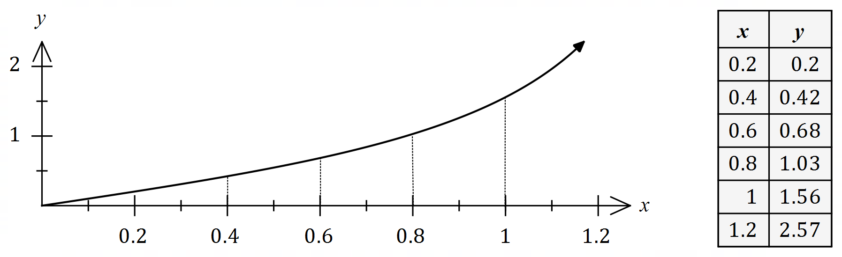
Let $I=\int_{0.4}^{1}{\underset{ }{\overset{ }{\tan{x}}}}dx$.

(a) By using the information shown and considering sums of the form $\sum_{i}{f\left(x_{i}\right)δx_{i}}$, explain
why $I>0.426$. (3 marks)

(b) In a similar manner to (a), determine the best estimate for the value of the constant $U$, where $I<U$. (2 marks)

(c) Use your previous answers to determine a numerical estimate for $I$ and explain whether your estimate is smaller or larger than the exact value of $I$. (2 marks)

Question 8 (6 marks)
The acceleration at time $t$ seconds of a small body travelling in a straight line is given by

$$a\left(t\right)=\frac{-3}{\sqrt{2t+3}} {\text{cm/s}}^{2}, t≥0.$$

When $t=3$ the body was at the origin and $8$ seconds later its displacement was $30$ cm.

Determine the velocity of the body when $t=6.5$.

Supplementary page

Question number: _________

© 2020 WA Exam Papers. Kennedy Baptist College has a non-exclusive licence to copy and communicate this document for non-commercial, educational use within the school. No other copying, communication or use is permitted without the express written permission of WA Exam Papers. SN245-165-1.

